

**AP Calculus AB**

Q2 Interim Assessment

January 2017

Section I – Part A (60 Minutes)

NO Calculators Allowed

Student Name: __________________________________________________

School: ___________________________________________________________

Teacher: _________________________________________________________

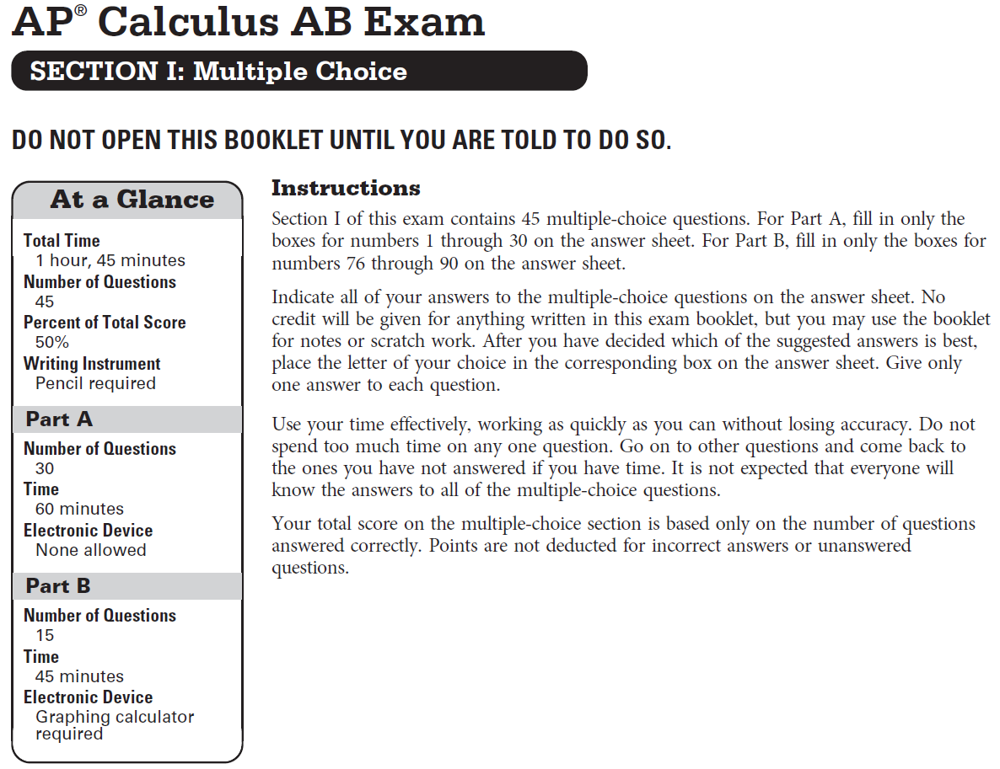

**­CALCULUS AB**

**SECTION I, Part A**

**Time – 60 minutes**

**Number of questions – 30**

**NO CALCULATOR IS ALLOWED FOR THIS PART OF THE EXAM.**

**Directions:** Solve each of the following problems, using the available space for scratch work. After examining the form for the choices, decide which of the choices given and place the letter of your choice in the corresponding box on the answer sheet. No credit will be given for anything written in this exam booklet. Do not spend too much time on any one problem.

**In this exam:**

1. Unless otherwise specified, the domain of a function $f$ is assumed to be the set of all real numbers $x$ for which $f\left(x\right)$ is a real number.
2. The inverse of a trigonometric function $f$ may be indicated using the inverse function notation $f^{-1}$ or with the prefix “arc” (e.g., $\sin^{-1}{x}=\arcsin{x}$).
3.  is
4. 0
5. 5
6. 10
7. Nonexistent
8. If , what is  at the point (–1, 3)?

(A) $-\frac{3}{5}$ (B) $\frac{3}{7}$ (C) $\frac{3}{5}$ (D) $\frac{6}{5}$

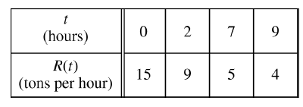

1. On a certain day, the rate at which material is deposited at a recycling center is modeled by the function $R$, where $R(t)$ is measured in tons per hour and $t$ is the number of hours since the center opened. Using a trapezoidal sum with three subintervals indicated by the data in the table, what is the approximate number of tons of material deposited in the first 9 hours since the center opened?

(A) 45 (B) 68 (C) 70.5 (D) 85

1. A particle moves along the *x*-axis so that at time  its position is given by . At what time *t* is the particle at rest?
2. *t* = 1 only
3. *t* = 3 only
4. *t* = 0 and t = 3
5. *t* = 1 and t = 3
6. If *f* is differentiable at *x* = *a*, which of the following could be false?
7. *f* is continuous at *x* = *a*.
8. $\lim_{x→a}{f(x)}$ exists.
9. $\lim_{x→a}{\frac{f\left(x\right)-f(a)}{x-a}}$ exists.
10. $\lim_{x→a}{\frac{f^{'}\left(x\right)-f^{'}\left(a\right)}{x-a}}$ exists

$\int_{1}^{4}{t^{-3/2}dt}=$

(A) $-1$ (B) $-\frac{7}{8}$ (C) $\frac{1}{2}$ (D) $1$

1. If , then 
2. 
3. 
4. 
5. 
6. Which of the following is an antiderivative of $3\sec^{2}{x}+2$?

(A) $3\tan{x}$

(B) $3\tan{x}+2x$

(C) $\sec^{3}{x}+2x$

(D) $6\sec^{2}{x}\tan{x}$

1. The length of a rectangle is decreasing at a rate of $2$ meters per second while the width of the rectangle is increasing at a rate of $2$ meters per second. At the instant when the length of the rectangle is $5$ meters and the width of the rectangle is $3$ meters, what is the rate of change of the area of rectangle in square meters per second?

(A) $-16$ (B) $-4$ (C) $4$ (D) $16$

1. The function *f* is continuous on the closed interval [2, 4] and twice differentiable on the open interval (2, 4). If  and  on the open interval (2, 4), which of the following could be a table of values of *f* ?

|  |  |  |  |  |  |  |  |  |  |  |
| --- | --- | --- | --- | --- | --- | --- | --- | --- | --- | --- |
| (A) | |  | (B) | |  | (C) | |  | (D) | |
| $$x$$ | $$f(x)$$ |  | $$x$$ | $$f(x)$$ |  | $$x$$ | $$f(x)$$ |  | $$x$$ | $$f(x)$$ |
| 2 | 2.5 |  | 2 | 2.5 |  | 2 | 3 |  | 2 | 3.5 |
| 3 | 5 |  | 3 | 5 |  | 3 | 5 |  | 3 | 5 |
| 4 | 6.5 |  | 4 | 7 |  | 4 | 6.5 |  | 4 | 7.5 |

1. Evaluate: 
2. –1
3. 0
4. 1
5. Undefined
6. The velocity of a particle along the $x$-axis is given by $v\left(t\right)=\sin{(t)}$ at time $t$. If the particle is at $x=4$ when $t=0$, what is the position of the particle when $t=\frac{π}{2}$?

(A) 3 (B) 4 (C) 5 (D) 6

1. If , then 
2. 
3. 
4. 
5. 
6. If , then 
7. 
8. 
9. 
10. 
11. If *c* is the number that satisfies the conclusion of the Mean Value Theorem for  on the interval , then *c* =
12. 0
13. 1
$\frac{4}{3}$

14. 2
15. Let *f* be a differentiable function such that , , , and. The function *g* is differentiable and  for all *x*. What is the value of ?

1. –1
2. 
3. 
4. 
5. 
6. $-30$ (B) $-15$ (C) $75$ (D) $78$
7. The table below gives values of the differentiable functions *f* and *g* and of their derivatives *f* ’ and *g*’, at selected values of *x*. If , what is the slope of the graph of *h* at *x* = 2?

|  |  |  |  |  |
| --- | --- | --- | --- | --- |
| $$x$$ | $$f(x)$$ | $$g(x)$$ | $$f'(x)$$ | $$g^{'}(x)$$ |
| $$-1$$ | $$-5$$ | 1 | 3 | 0 |
| 0 | $$-2$$ | 0 | 1 | 1 |
| 1 | 0 | $$-3$$ | 0 | 0.5 |
| 2 | 5 | $$-1$$ | 5 | 2 |

(A) -5 (B) 3 (C) 6 (D) 10

1. Let $f$ be the function defined by $f\left(x\right)=\frac{\left(3x+8\right)\left(5-4x\right)}{{\left(2x+1\right)}^{2}}$. Which of the following is a horizontal asymptote to the graph of $f$?

$y= -6$

$y= -3$

$y=0$

$y=\frac{3}{2}$

$\lim_{x→0}{\frac{x^{2}}{1-\cos{x}} is}$

(A) $-2$ (B) $0$ (C) $2$ (D) nonexistent

1. The velocity of a particle moving along the $x$-axis is shown below for $0<t<4$. The graph has horizontal tangents at $t=1$ and $t=3$, and a zero at $t=2$. For what values of $t$ is the speed of the particle decreasing?

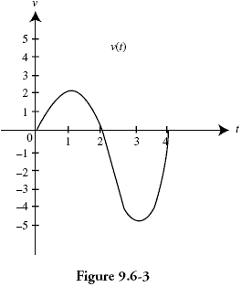

1.  only
2.  only
3.  only
4.  and 
5. Given  on the closed interval , the absolute minimum occurs at *x* =

(A) –2 (B) 0 (C) 2 (D) 4



$\int{\frac{3x^{2}+6x}{6\sqrt{x}}}dx=$

(A) $\frac{1}{2}x^{3/2}+x^{1/2}+C$

(B) $\frac{1}{5}x^{5/2}+\frac{2}{3}x^{3/2}+C$

(C) $\frac{3}{4}x^{1/2}+\frac{1}{2}x^{-1/2}+C$

(D) $\frac{x^{3}+5x^{2}}{4x^{3/2}}+C$

1. The value of  is
2. –6
3. –2
4. 10
5. 18
6. The function *f* is twice differentiable with , , and . What is the value of the approximation of  using the tangent line to the graph of *f* at *x* = 4?

(A) 5.7 (B) 5.8 (C) 5.9 (D) 6.3

1. Let *f* be the function given by . The graph of *f* is concave down when
2. 
3. 
4.  and 
5.  and 
6. If  and , then 
7. *C* + *D*
8. *C* – *D*
9. *D* – *C*
10. 500
11. 
12. 
13. 
14. 
15. 

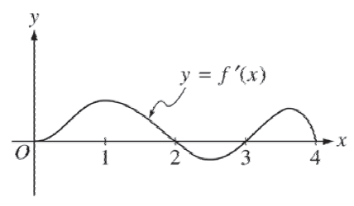

1. The figure above shows the graph of $f'$, the derivative of the function $f$. If $f\left(0\right)=0$, which of the following could be the graph of $f$?

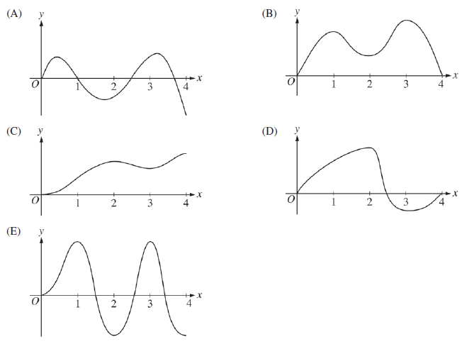

1. Find two non-negative numbers $x$ and $y$ whose sum is 100 and corresponds to the maximum value of $x^{2}y$.

(A) $x=33.333$ and $y=33.333$

(B) $x=50$ and $y=50$

(C) $x=33.333$ and $y=66.667$

(D) $x=66.667$ and $y=33.333$

**END OF PART A**

**IF YOU FINISH BEFORE TIME IS CALLED,**

**YOU MAY CHECK YOUR WORK ON PART A ONLY.**

**DO NOT GO ON TO PART B UNTIL YOU ARE TOLD TO DO SO**